Test Case: runTestMultipleTimes
Step 1 - Enter username and password and click to button Enter : Credentials Entered
Image file-name: QC_Testing-runTestMultipleTimes-dic. 04 2025, 03 46 30 p. m.

Image file-name: QC_Testing-runTestMultipleTimes-dic. 04 2025, 03 46 31 p. m.

Step 2 - Select to UEN and Access to Spot Buy Requisitions : UEN Correctly selected and Correct access
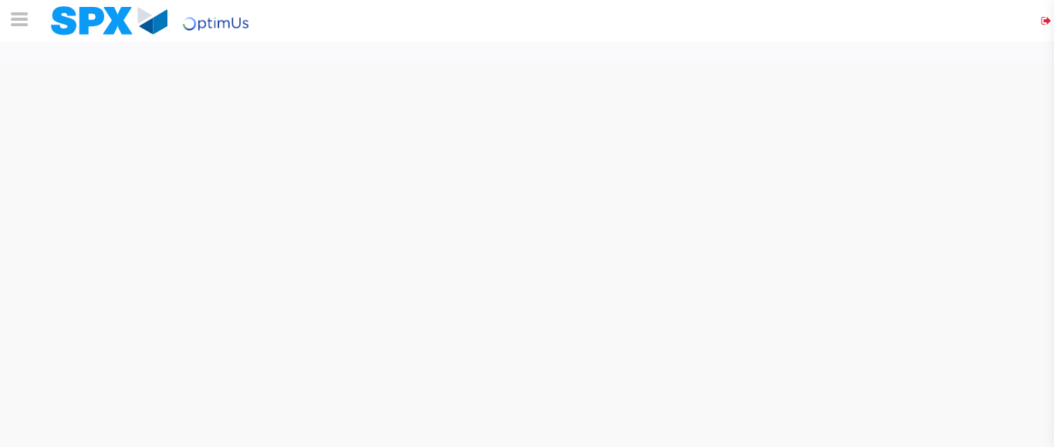Image file-name: QC_Testing-runTestMultipleTimes-dic. 04 2025, 03 46 34 p. m.

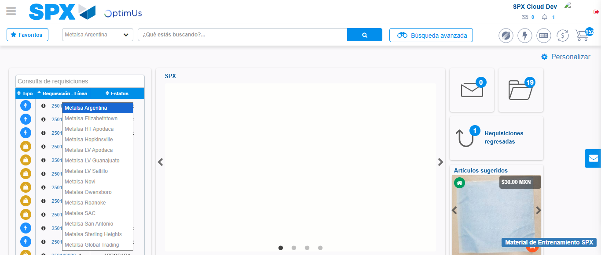Image file-name: QC_Testing-runTestMultipleTimes-dic. 04 2025, 03 46 35 p. m.

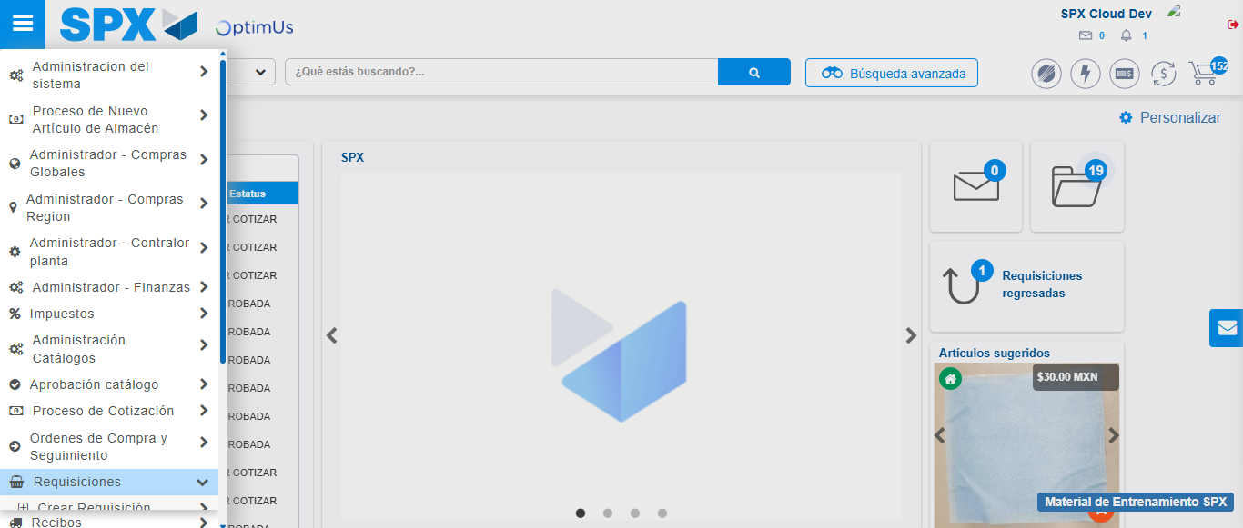Image file-name: QC_Testing-runTestMultipleTimes-dic. 04 2025, 03 46 36 p. m.

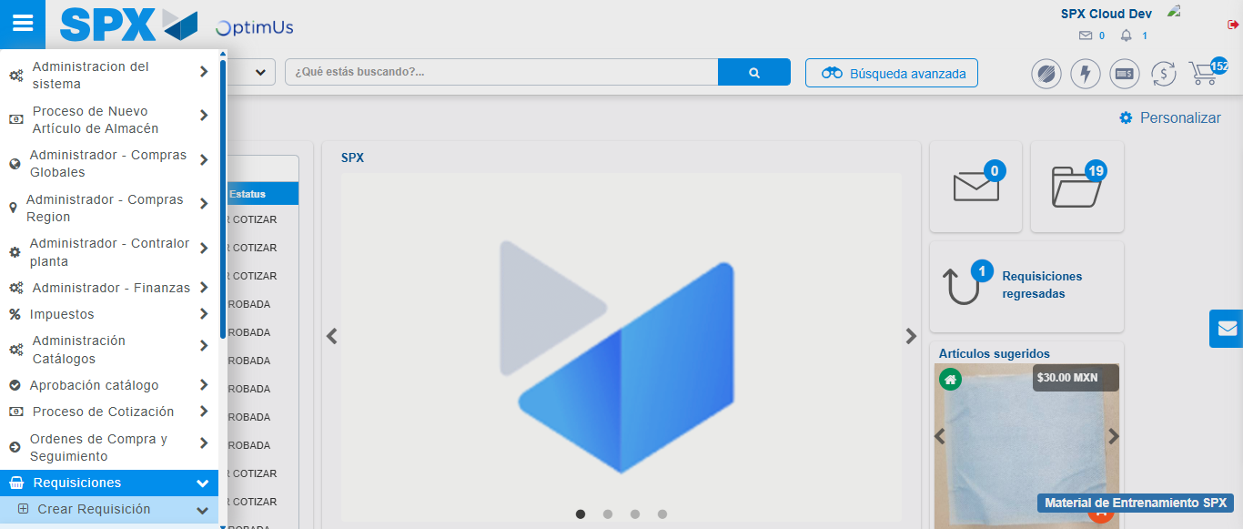Image file-name: QC_Testing-runTestMultipleTimes-dic. 04 2025, 03 46 37 p. m.

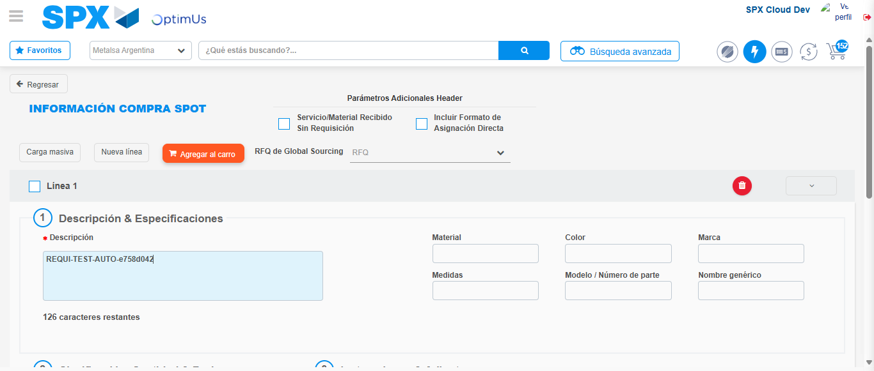Image file-name: QC_Testing-runTestMultipleTimes-dic. 04 2025, 03 46 42 p. m.

Step 3 - Data Capture Spot Buy Requisition: Data captured correctly
Image file-name: QC_Testing-runTestMultipleTimes-dic. 04 2025, 03 46 42 p. m.

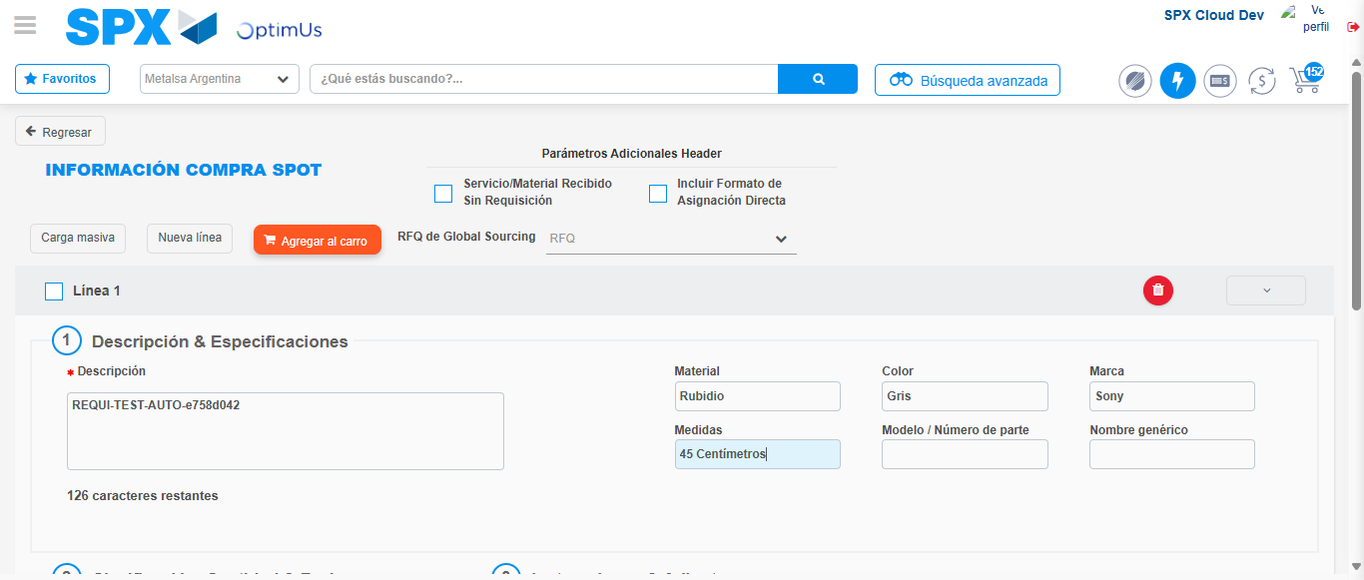Image file-name: QC_Testing-runTestMultipleTimes-dic. 04 2025, 03 46 43 p. m.

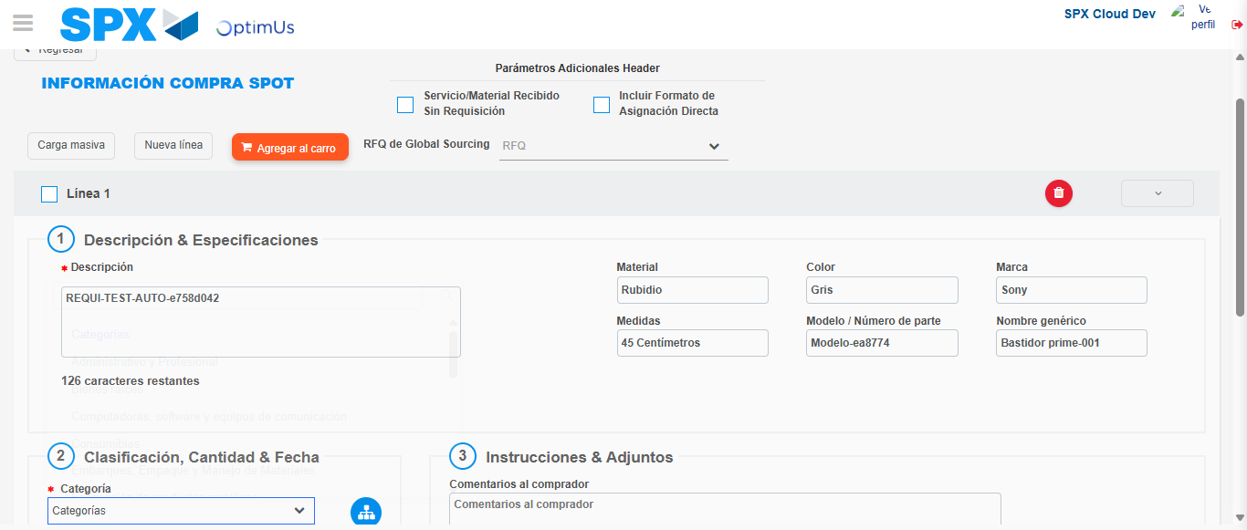Image file-name: QC_Testing-runTestMultipleTimes-dic. 04 2025, 03 46 44 p. m.

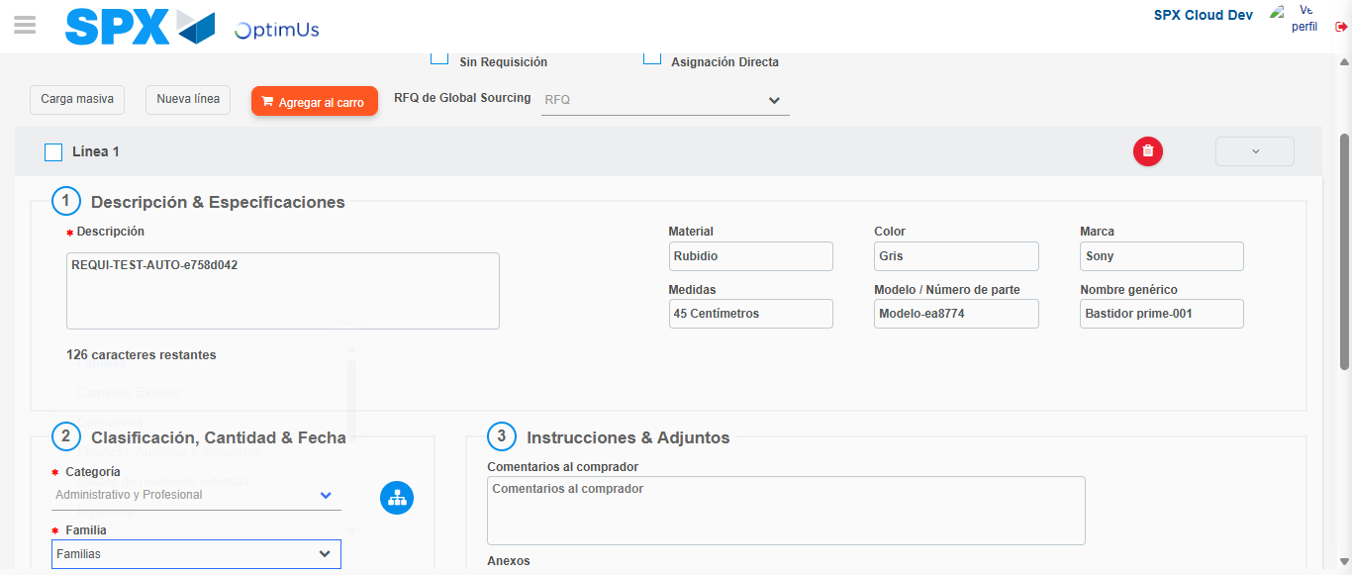Image file-name: QC_Testing-runTestMultipleTimes-dic. 04 2025, 03 46 45 p. m.

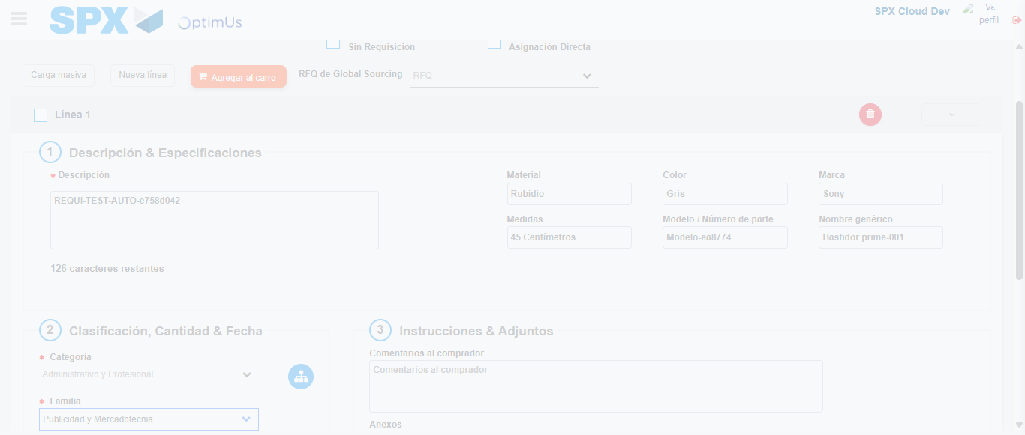Image file-name: QC_Testing-runTestMultipleTimes-dic. 04 2025, 03 46 46 p. m.

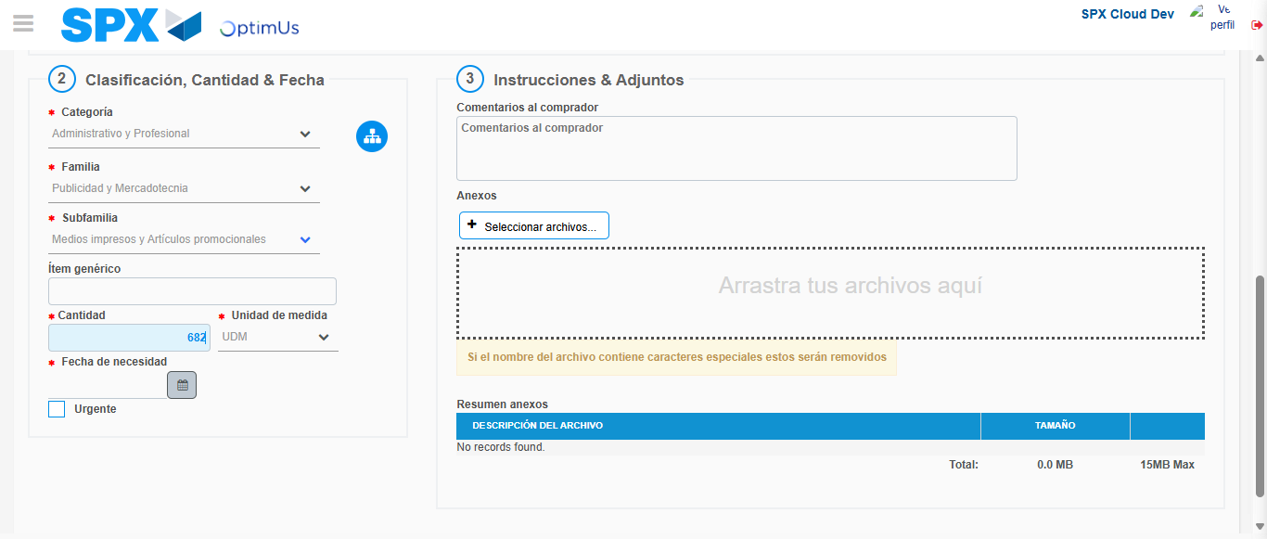Image file-name: QC_Testing-runTestMultipleTimes-dic. 04 2025, 03 46 47 p. m.

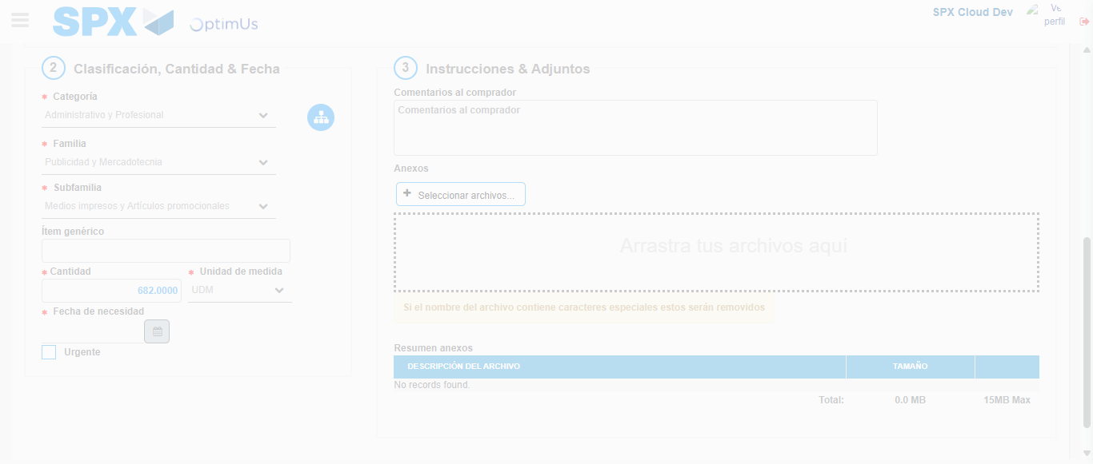Image file-name: QC_Testing-runTestMultipleTimes-dic. 04 2025, 03 46 48 p. m.

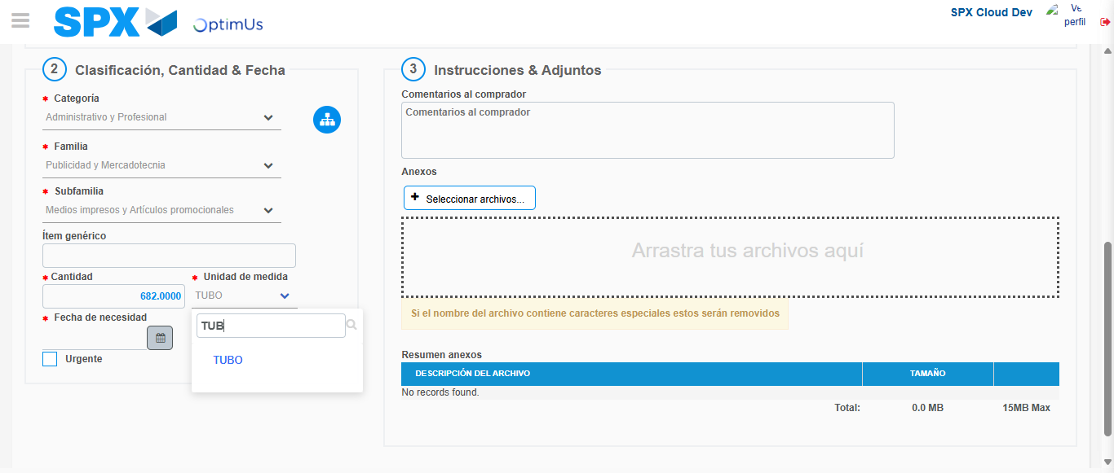Image file-name: QC_Testing-runTestMultipleTimes-dic. 04 2025, 03 46 49 p. m.

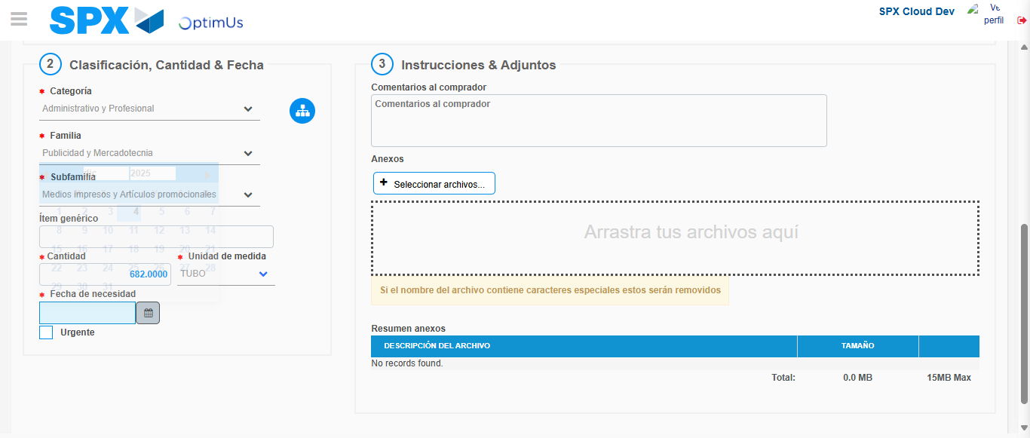Image file-name: QC_Testing-runTestMultipleTimes-dic. 04 2025, 03 46 50 p. m.

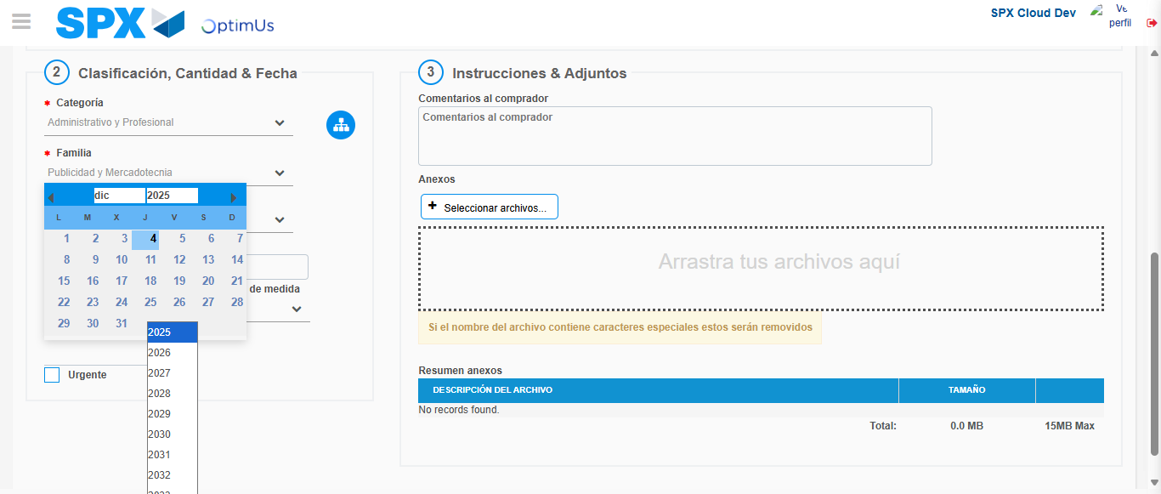Image file-name: QC_Testing-runTestMultipleTimes-dic. 04 2025, 03 46 51 p. m.

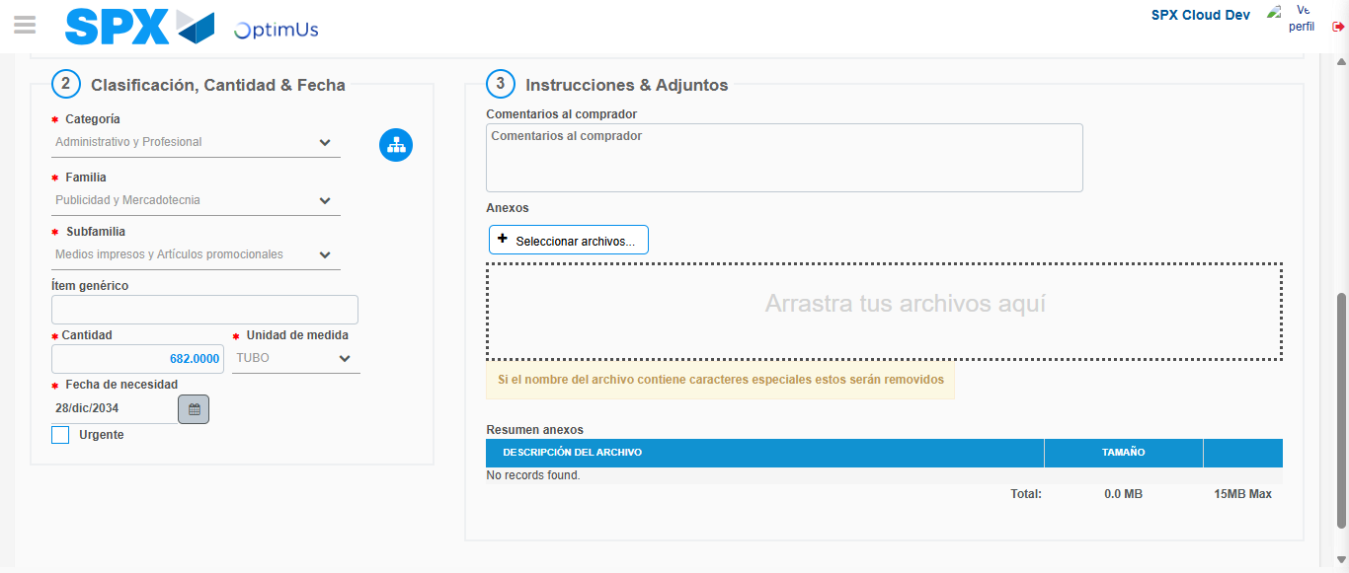Image file-name: QC_Testing-runTestMultipleTimes-dic. 04 2025, 03 46 52 p. m.

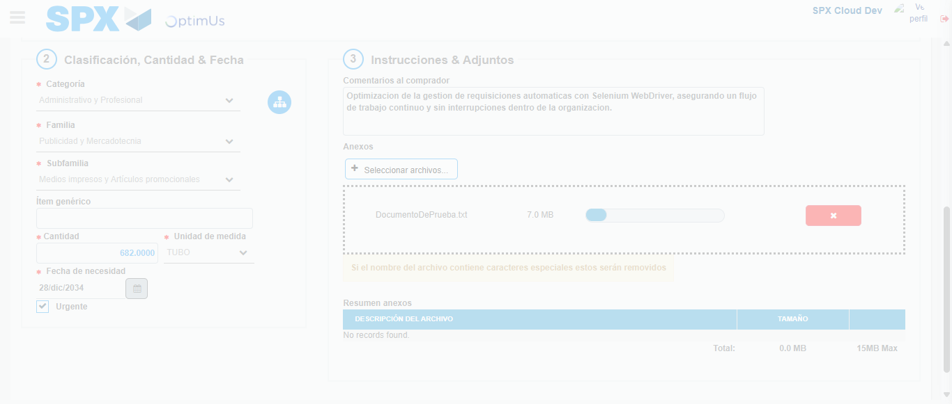Image file-name: QC_Testing-runTestMultipleTimes-dic. 04 2025, 03 46 53 p. m.

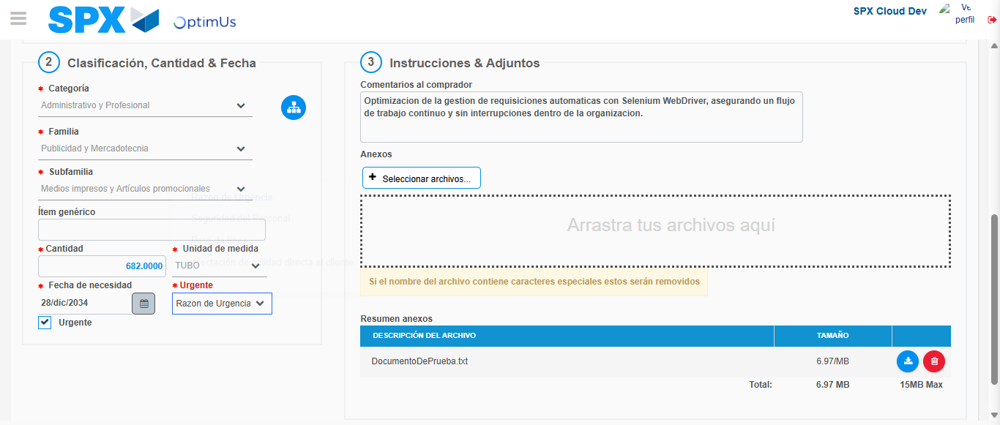Image file-name: QC_Testing-runTestMultipleTimes-dic. 04 2025, 03 46 58 p. m.

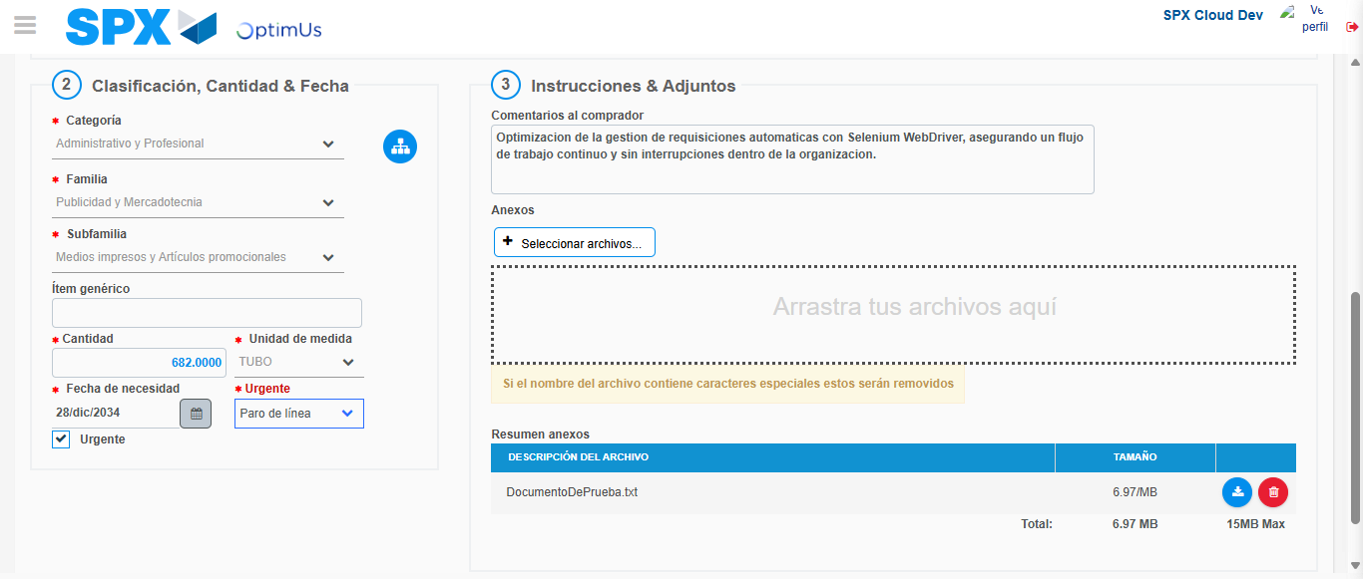Image file-name: QC_Testing-runTestMultipleTimes-dic. 04 2025, 03 46 59 p. m.

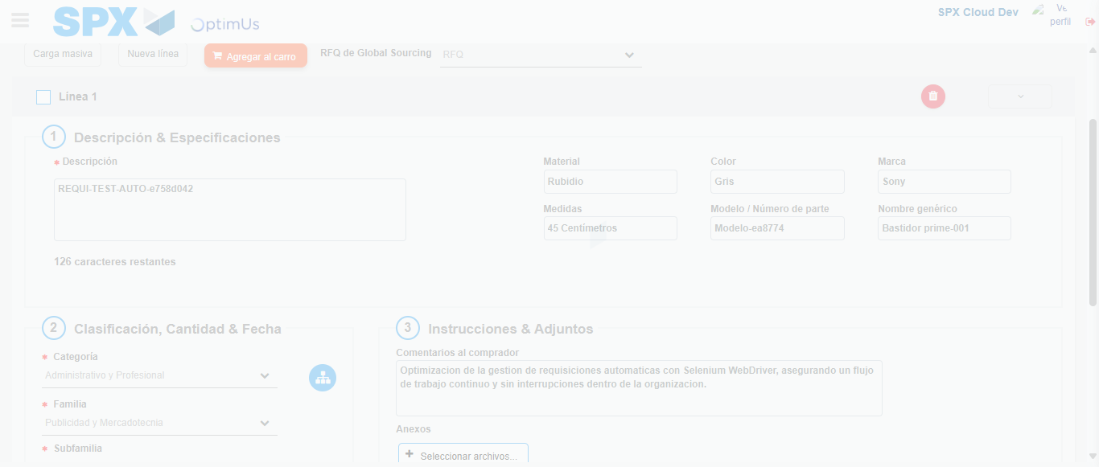Image file-name: QC_Testing-runTestMultipleTimes-dic. 04 2025, 03 47 02 p. m.

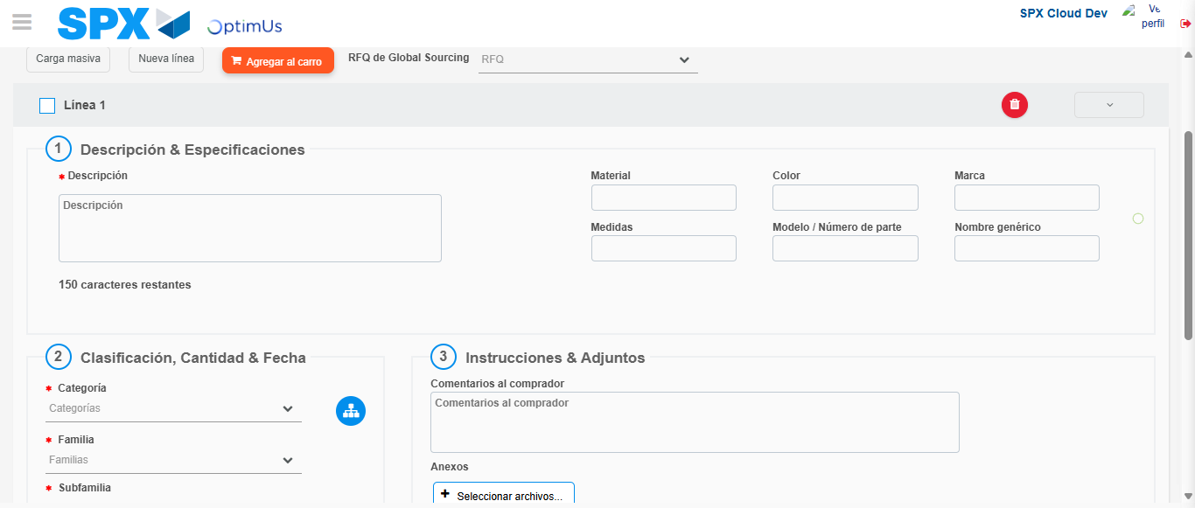Image file-name: QC_Testing-runTestMultipleTimes-dic. 04 2025, 03 47 04 p. m.

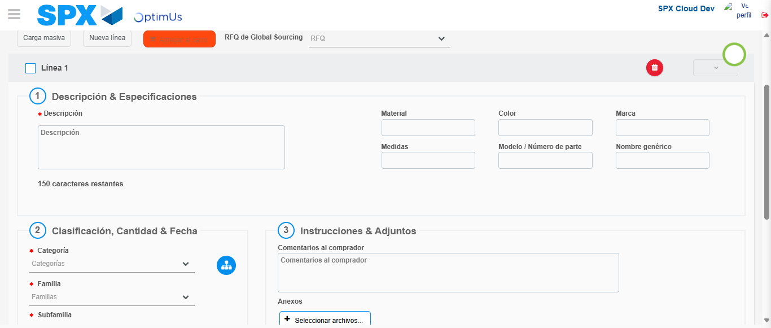Image file-name: QC_Testing-runTestMultipleTimes-dic. 04 2025, 03 47 05 p. m.

Step 4 - Select to Requisition: Requisition Correctly selected
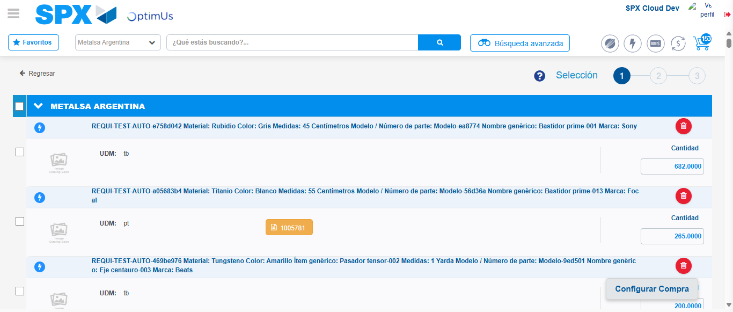Image file-name: QC_Testing-runTestMultipleTimes-dic. 04 2025, 03 47 13 p. m.

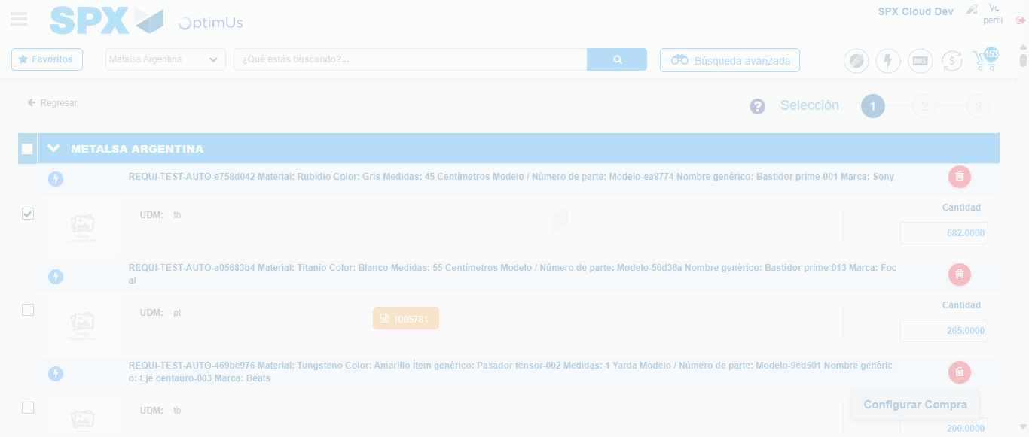Image file-name: QC_Testing-runTestMultipleTimes-dic. 04 2025, 03 47 14 p. m.

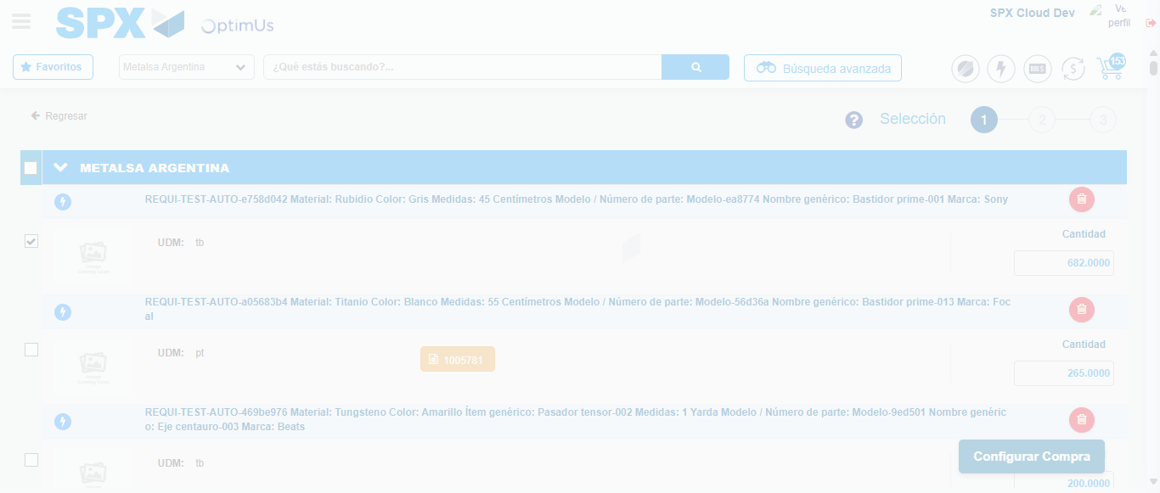Image file-name: QC_Testing-runTestMultipleTimes-dic. 04 2025, 03 47 17 p. m.

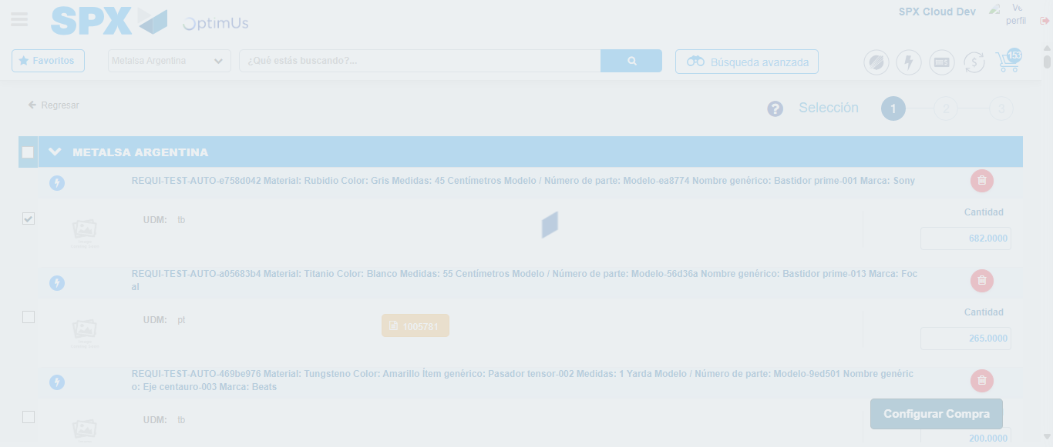Image file-name: QC_Testing-runTestMultipleTimes-dic. 04 2025, 03 47 18 p. m.

Step 5 - Select Type Account For Requisition: Type Account Correctly selected
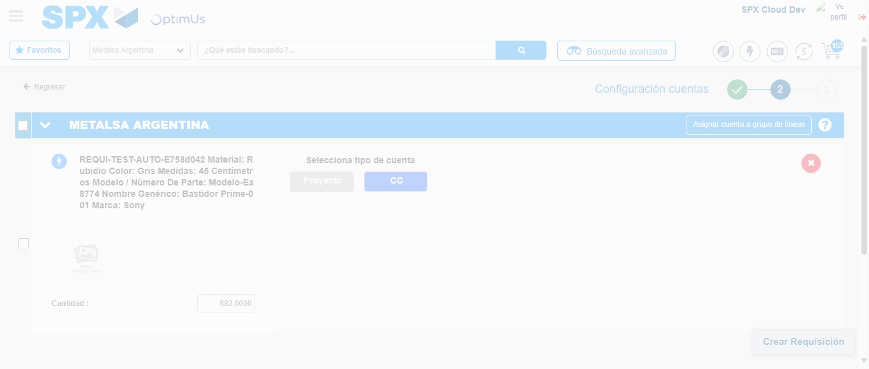Image file-name: QC_Testing-runTestMultipleTimes-dic. 04 2025, 03 47 20 p. m.

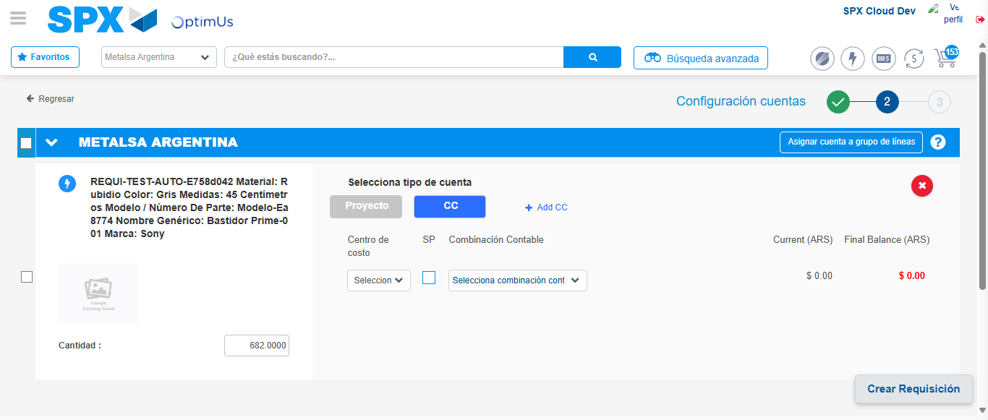Image file-name: QC_Testing-runTestMultipleTimes-dic. 04 2025, 03 47 23 p. m.

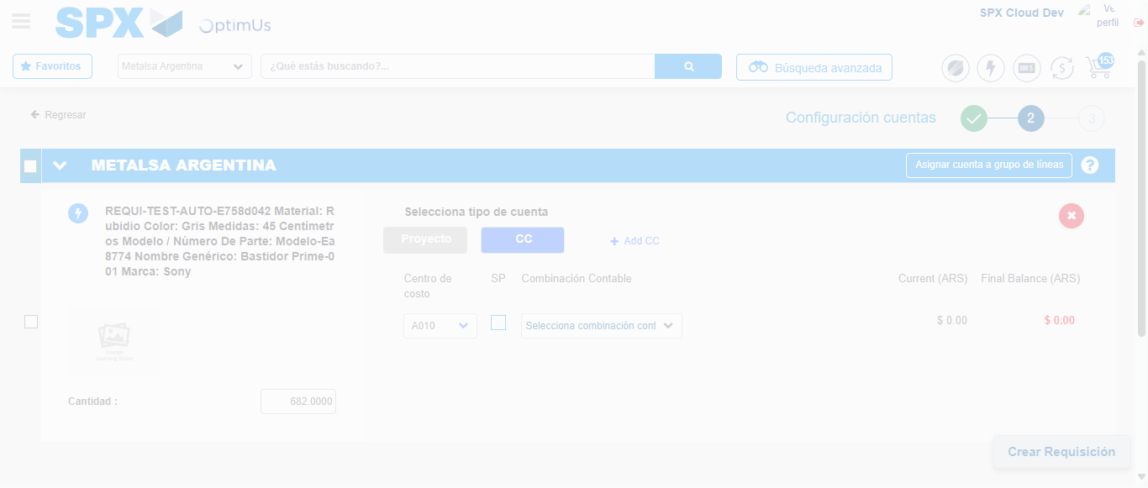Image file-name: QC_Testing-runTestMultipleTimes-dic. 04 2025, 03 47 27 p. m.

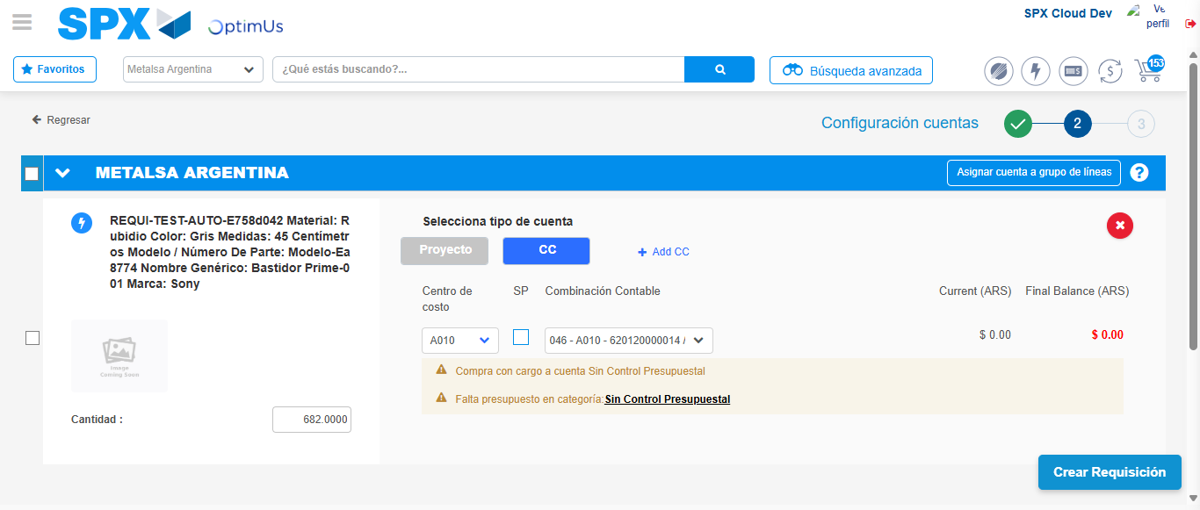Image file-name: QC_Testing-runTestMultipleTimes-dic. 04 2025, 03 47 30 p. m.

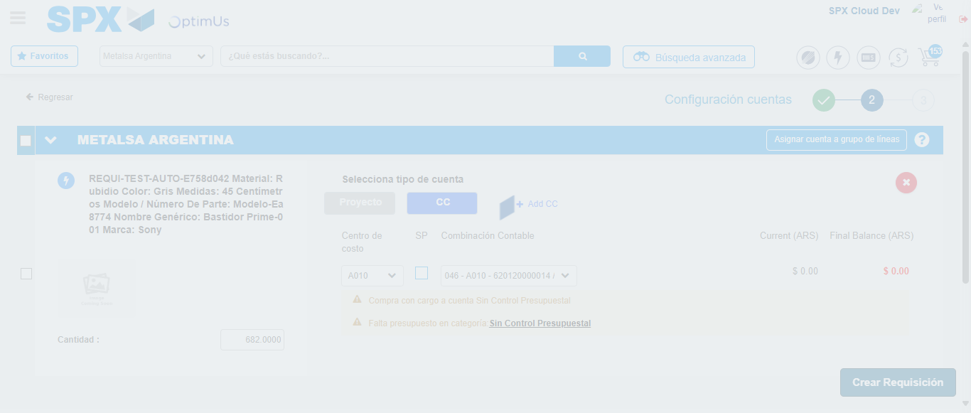Image file-name: QC_Testing-runTestMultipleTimes-dic. 04 2025, 03 47 31 p. m.

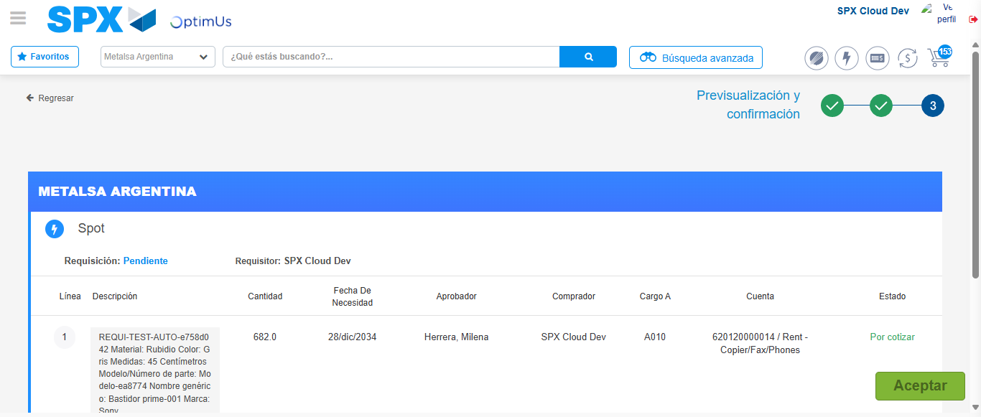Image file-name: QC_Testing-runTestMultipleTimes-dic. 04 2025, 03 47 34 p. m.

Step 6 - Accept to Requisition: Requisition Accepted
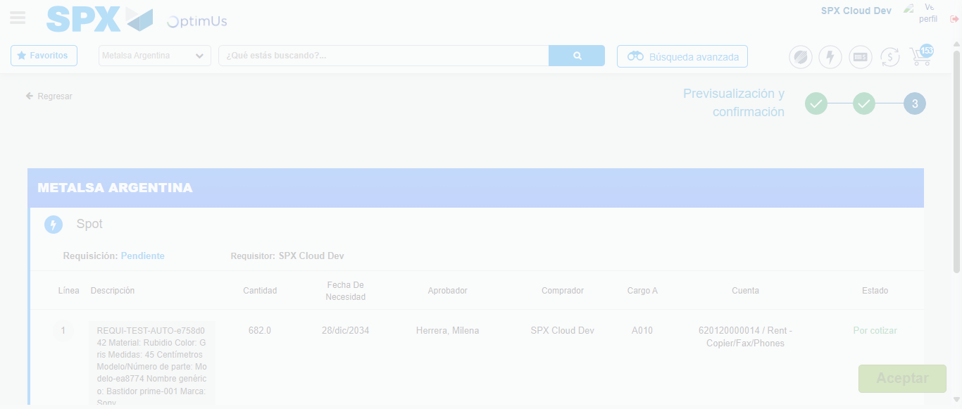Image file-name: QC_Testing-runTestMultipleTimes-dic. 04 2025, 03 47 35 p. m.

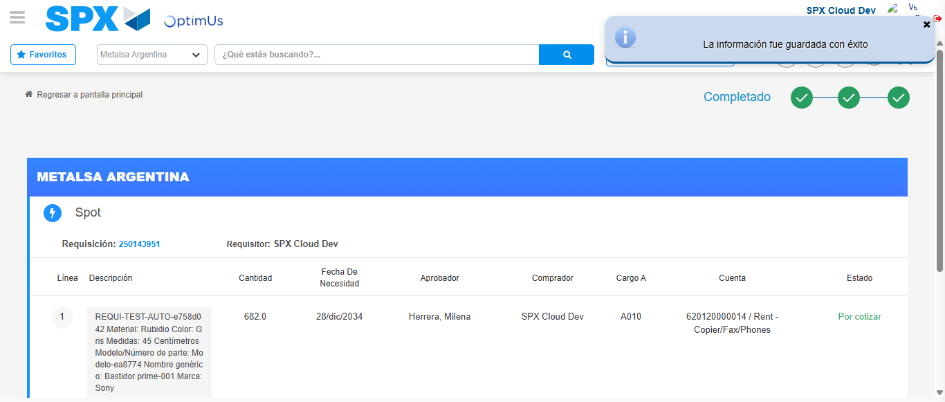Image file-name: QC_Testing-runTestMultipleTimes-dic. 04 2025, 03 47 38 p. m.

